

APSI’s RFIC Feasibility Study Material

Revision 0.***
Document Number: ******

Asia Pacific Satellite Industries Co.,Ltd
Bldg. IT Castle 2, 9th Fl, 550-1 Gasan-dong, Gumchun-gu
Seoul, Korea

Copyright © 2006 Asia Pacific Satellite Industries Co., Ltd
All Rights Reserved
APSI Proprietary

All information contained in or disclosed by this document is confidential and proprietary to APSI. By accepting this material the recipient agrees that this material and the information contained therein will be held in confidence and will not be reproduced in whole or in part without express written permission from APSI.
1. RF block diagram
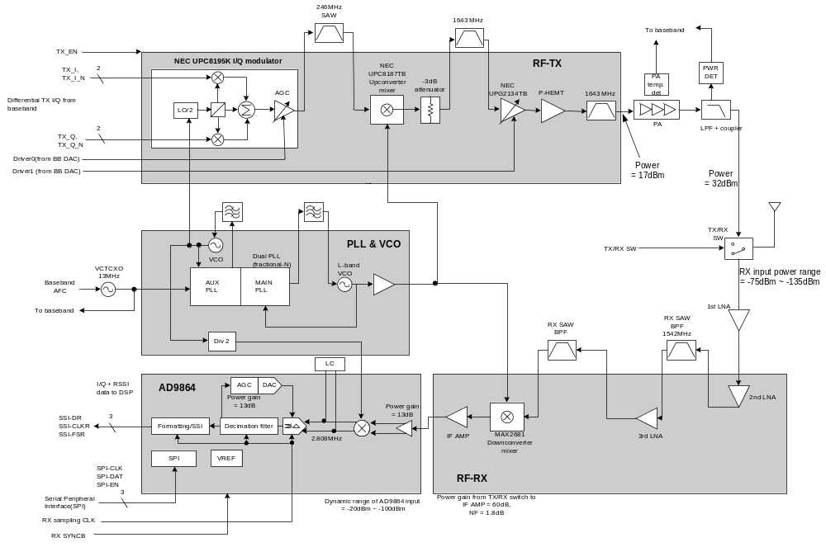
2. Receiver
1) RX carrier frequency: 1525 ~ 1559 MHz
2) RX input power range: -135dBm ~ -75dBm
3 1st LNA: GaAs E-PHEMT used. Noise blocking from the transmitter and power supply circuitry
4) Power gain from 1st LNA to IF AMP: 60dB
5) NF from 1st LNA to IF AMP: 1.8dB
6) Analog Devices’ AD9864 (IF digitizing subsystem)
- Input dynamic range: -100dBm ~ -20dBm
- LNA: gain 13dB
- Sigma-Delta ADC (AGC gain: 13dB)
- decimation filter
- post-sampling process
7) Receiver G/T and derived NF: -24 dB/K, 2.63 dB
8) Receiver selectivity interference conditions
case | Interference relative to sensitivity | Interference frequency offset
1 | +15dB | 31.25kHz
2 | +25dB | 93.75kHz
3 | +45dB | >500kHz

9) Receiver LO phase noise requirements

Frequency offset(kHz) | Expected RF phase noise | Expected IF phase noise
31.25 | -86.6 dBc/Hz | -83.6 dBc/Hz
93.75 | -96.6 dBc/Hz | -93.6 dBc/Hz
>500 | -116.6 dBc/Hz | -113.6 dBc/Hz

10) To ensure 6dB of SNR, IM3=-40dB, IIP3=-46dBm are needed
11) in-band blocking: -70dBm

3. Transmitter

1) TX-I/Q-Modulator: Differential in-phase and quadrature signals(I+, I-, Q+, Q-) from the baseband are inputted. After low pass filter the signals are up-converted to 246MHz, and then pass a variable gain stage.
Divide-by-2 circuit is needed to convert 492MHz of IF LO to 246MHz.
Modulator power supply is controlled by TX_EN from baseband.
2) TX up-converter: 246 MHz → 1626.5 ~ 1660.5 MHz
- conversion gain: around 10dB
- clock input from RF LO (1380.5 ~ 1414.5 MHz)
3) TX driver Amp.: control voltage is 0.5 ~ 2.5V
- Maximum power at 1.65V. Gain is 12 ~ 16dB.
- power supply is controlled by TX_EN from baseband.
4) Power at input of Power Amp: 17dBm

4. Frequency Synthesizers

1) 13 MHz VCTCXO is reference clock. It is controlled by AFC of baseband.
2) Phillips SA8028 dual synthesizer is used. RF PLL is sigma-delta fractional-N, and IF PLL is integer-N.
3) IF VCO: stable performance 492MHz is fed to transmitter and receiver.
4) L-band VCO: single loop filter. Output of VCO passes dual buffer/amp. One is fed back to dual PLL and the other is fed to transmitter/receiver’s converter through Wilkinson driver.

